**PROJECT REPORT ON**

# BABY CARE

***Submitted in partial fulfllment of the requirements for the award of degree of***

## BACHELORR OF COMPUTER APPLICATION

**MAHATMA GANDHI UNIVERSITY KOTTAYAM**

**By,**

# ARCHANA MK

## Reg. No: 190021092727

***Under the guidance and supervision***

***of***

## Mrs. RAJASREE G

**(Asst Prof, STAS, Pathanamthitta)**



## SCHOOL OF TECHNOLOGY AND APPLIED SCIENCES

CENTRE FOR PROFESSIONAL AND ADVANCED STUDIES

**(Established by Government of Kerala)**

## AFFILIATED TO MAHATHMA GANDHI UNIVERSITY

Chuttippara, Pathanamthitta, 689



# SCHOOL OF TECHNOLOGY AND APPLIED SCIENCES

CENTRE FOR PROFESSIONAL AND ADVANCED STUDIES

(**Established by Government of Kerala**) **AFFILIATED TO MAHATHMA GANDHI UNIVERSITY**

Chuttippara, Pathanamthitta, 689645

# CERTIFICATE

This is to certify that the project report entitled “**BABY CARE**” submitted in partial fulfilment of the degree of Bachelor in Computer Science from the Mahatma Gandhi University during the period from March 2022 to May 2022 done by **ARCHANA MK( Reg No: 190021092727 )** is an authentic work carried out by him under my guidance. The matter embodied in this project work has not been submitted earlier for award of any degree or diploma to the best of my knowledge and belief.

**Internal Examiner Signature of the Guide**

**External Examiner Principal**

# DECLARATION

I hereby declare that the project report entitled **“BABY CARE”** submitted to the Mahatma Gandhi University , Kottayam in partial fulfilment of the requirements for the award of degree of Bachelor of computer application is a record of original work done during my period of study in **School of Technology and Applied Science, Pathanamthitta,** work done under the guidance of Assistant Professor **Mrs**. **RAJASREE G,** STAS, Pathanamthitta.

**Name of Candidate : ARCHANA MK**

**Register Number : 190021092727**

**ACKNOWLEDGMENT**

The satisfaction that accompanies the successful completion of any task would be incomplete without mentioning about the people who made it possible whose constant guidance and encouragement has crowned the efforts with success.

First and foremost , I am extremely grateful to the Project Guides

**Mrs RAJASREE G,** under whose guidance I would complete this project.

I would like to express our sincere thanks to **Mrs REMA K**, Principal of STAS Pathanamthitta who has kind enough to grant us the opportunity to work on this project.

I am obliged to all other faculty members of the department of BCA, STAS Pathanamthitta for their valuable suggestions and co-operation. Last but not least, I am thankful to my colleagues and friends who all helped to complete my project.

This project has been carried out as part of the requirement of Bachelor of computer application and it is submitted with extreme pleasure and gratitude.

## ARCHANA MK

**TABLE OF CONTENTS**

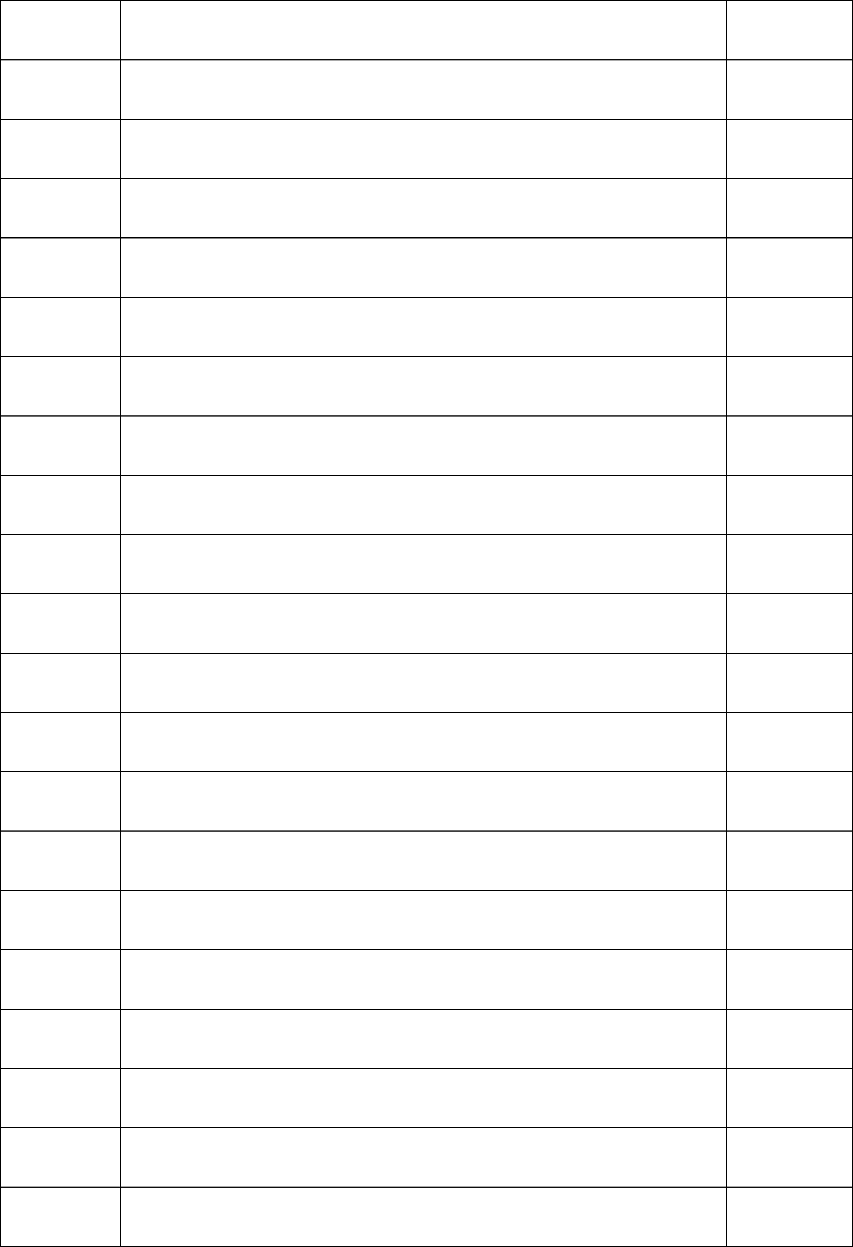

# 

# 1 . PROFILE OF THE PROBLEM

**1.1 ABOUT THE PROJECT**

The project brings the entire manual process of work of asha’s worker online. The main purpose of this project is to simplify the process of handling each event by providing a web interface for admin, worker and parents, doctors.

The admin module consists of register each worker and allot each worker to different locations and view the overall work of worker and add panchayath, projects and doctor and it viewing. The worker module consists of register parent have child less than 5 years old, providing baby food, alert vaccination details, date of vaccination, manage the health of both mother and child, add details of diseases etc. The parent module consists view the view the vaccination details, view the details about the nutrition foods, diseases so.

The existing baby care system normally there is no way to alert mothers about vaccination details or food details Eg.: pulse polio vaccination. It is very important for child up to 5years.Also about the food details for children and pregnant. The new Panchayath programs, health center programs and Government schemes are unavailable to public. The Asha worker not bother about new born child’s and mothers. There are 4 modules in the system as following admin, worker, mother and doctor.

**2 . SYSTEM ANALYSIS**

## INTRODUCTION

System analysis is the process of gathering data and facts diagnosing problem to the system. In the development of software structural analysis is required. During this analysis, information is collected in the form of answers to the question for collecting information from existing documents. Analysis specifies what the system should do.

Problem definition deals with defining the actual problem involved in the existing system or the system to be developed. Studies on various areas covered by the existing system are classified into various divisions and the actual task to be performed in the new system is determined. The project will be able to demonstrate the ideas of a website which helps the public. The website is trying to revitalize and simplify the various functions and activities and make them more people friendly. We dedicated to provide better and speedy services to the public.

System analysis is the detailed study of various operations and their relationship within and outside the system. It is the first in the developing and managing systems. System analysis is concerned with becoming aware of the problem, identifying the relevant and most decision0 variables, analyzing and synthesizing the various factors and determining an optimal or at least as at is factory solution or program of action. A preliminary study was conducted in details and several fact-finding techniques like record searching, observation, comparison etc. were used to reach a better decision. The current system for this each activity was deeply studied and analyzed. All the forms and other printed or non-printed formats for data collection were checked accurately and findings were compared. Observation was done to great extend to see the difficulties of the process and time delay in findings the results. Accurate study was conducted to know the system in a much better manner.

The objectives of the system analysis are

* Identifying the need.
* Analyzing the existing and proposed system.
* Evaluating the feasibility study.
* Perform economic and technical analysis.
* Identifying the hardware and software requirements.
* Allocating functions to the hardware and software

## 2.2 EXISTING SYSTEM

In the existing system normally, there is no way to alert mothers about vaccination details or food details Egg: pulse polio vaccination. It is very important for child up to 5 years. Also, about the food details for children and pregnant. The new Panchayath programs, health center programs and Government schemes are unavailable to public. The Asha worker not bother about new born child’s and mothers.

## 2.3 PROPOSED SYSTEM

The Baby care consist of four users, Government, Panchayath, Asha’s worker and Mother/pregnant women. In this application, Government can view all reports of Panchayath The Government (Admin) add Panchayath and publish all schemes (e.g.: Maternity Benefit Programmed) of government through this application and Asha’s workers and Users can view these schemes through this website. Panchayath are managed by admin and can view report by district wise. Panchayath add all programs conduct by panchayath and Asha’s worker and Users can view all these programs. Asha’s worker informs relevant user’s availability of food, vaccination conducting details and program conducting details. Users and Asha’s worker can access these websites at anywhere. Additionally, this website give other information, which vaccinations you may or may not need during your pregnancy and acts as a child’s healthcare provider if your child is up to date with all recommended vaccines.

## 2.3.1 BENEFITS OF THE PROPOSED SYSTEM

* + - * Convenient.
      * Time saving.
      * Information is private and confidential.
      * Access appointments on your computer, laptop and mobile phone
      * Anytime anywhere.
      * Easy and secured

# 

# SYSTEM DEVELOPMENT

#### **3.1 MODULE DESCRIPTION**

**Admin**

* + Registration Module
  + View Vaccination Details
  + View Food Details
  + View Disease Details
  + View Details of parent and child
  + View Tips

#### **Worker**

* + Add Mothers
  + Add Vaccination Details
  + Alert Vaccination Dates to parents
  + Add Food Details
  + Add Disease Details
  + Add Health Care Details
  + Distribute Food
  + Add Basic Tips To care child

#### **Mothers**

* + View Vaccination Details
  + View Food Details
  + View Disease Details
  + View Health Care Tips
  + Distribution Food Details
  + View tips

**4 . PROBLEM ANALYSIS**

FEASIBILITY STUDY

During the system analysis study of the proposed system is carried out to see whether it is carried out to see whether it is beneficial to the organization. It is both needed and prudent to evaluate the feasibility of a project at the earliest time and minimum expenditure. Feasibility study is a test of system proposal access, its workability, impact on the organization, ability to meet the user needs, and effective use of resources. The different steps involved in feasibility analysis are.

* Formation of a project team
* Preparing the system flow chart
* Enumerating the potential candidate system
* Identifying the candidate system

The proposed system will help to solving the problem more efficiently and accurately. The reports obtained after feasibility studies are given below, they are:

* Economic Feasibility
* Technical Feasibility
* Operational Feasibility

**4.1.1 Economic Feasibility**

It will reduce expenditure and improve the quality of service. A system can develop technically and that will used if the installed must still be a good investment for the organization. Financial benefits must exceed the cost. In the case of proposed system, performance of the system is effective of its accuracy, faster response and user friendly in nature.

#### **4.1.2 Technical Feasibility**

Technical Feasibility checks the work for the project be done with current equipment, existing software technology and available personal. And if technology is required, what is the likelihood that it can develop. Also checks whether the proposed system guarantees accuracy, reliability, data security and ease of access. All the resources or implementing this software is available in this project. So, we can say it is technically feasibility.

#### 

#### **4.1.3 Operational Feasibility**

People are inherently to change, and computers have been known to facilitate chance. An estimate should be made about the reaction of the user, staff towards the development of a computerized system. Computer installations have something to do with turnover, transfer and changes in job status. Proposed projects are beneficial only if that can be turned in to information system that will meet the organizations operating requirements. In-operational feasibility study the management and users were found to have interest for a chance. Since the system is user friendly and training is less needed

#### **PROJECT PLAN**

Planning is very important in every aspect of development work. Good managers carefully monitor developments at various phases. Improper planning leads to failure of the project. Software project plan can be viewed as the following:

1. Within the organization: How the project is to be implemented? What are various constraints? What is market strategy?
2. With respect to the customer: Weekly or timely meetings with the customer with presentations on status reports. Customer feedback is also taken and further modifications and developments are done. Project milestones and deliverables are also presented to the customer.

For a successful project the following steps can be followed:

1. Selection of project: Includes identifying project’s aims and objectives, understanding requirements and specification, methods of analysis, design and implementation, testing techniques and documentation.
2. Project milestones and deliverables
3. Project estimates: including cost, time, size of code and duration
4. Resource allocation: including hardware, software, previous relevant project information and digital library
5. Risk management: including risk avoidance, risk detection, risk control and risk recovery
6. Scheduling techniques: including work breakdown structure, activity graph, critical path method, Gantt chart and Program Evaluation Review Technique.
7. People: including staff recruitment, team management and customer interaction.

Quality control and standard

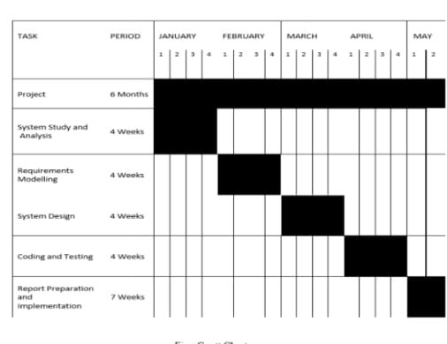

1. **. REQUIREMENT ENGINEERING**

## 5.1 SYSTEM SPECIFICATION

The software requirements specification (SRS) is a means of translating the ideas in the minds of clients into a formal documentation. This document forms the development and software validation. The basic reason for the difficulty in software requirement specification comes from the fact that there are three interested parties-the clients, the end users and the software developer. The requirements document has to be such that the client and the user can understand easily and the developers can use it as a basis for software development. Due to the diverse parties involved in software requirement specification, a communication gap exists. This gap arises when the client does not understand software or the software development processor when the developer does not understand the client’s problem and application area. Sirs bridges this communication gap.

Problem analysis is done to obtain a clear understanding of the needs of the clients and the users, and what exactly is desired from the software. Analysis leads to the actual specification. People performing the analysis called analysts, area also responsible for specifying the requirements.

The software project is initiated by the client’s needs. In the beginning these needs are in the minds of various people in the client organization. The requirement analyst has to identify their requirements by talking to these people and understanding their needs. These people and the existing documents about the current mode of operation are the basis source of information for the analyst.

**5.1.1 HARDWARE SPECIFICATION**

MACHINE : INTEL DUAL

CORE MOTHER BOARD : INTEL 945

CHIPSET MEMORY : 4 GB

HARD DISK : 500 GB

MONITOR : 18.5” LED MONITOR

KEYBOARD : USB/3

MOUSE : USB/

## 5.1.2 SOFTWARE SPECIFICATION

Operating system : Windows

Web technologies : python, Django, html, CSS

Database : MySQL

Web browser : Google Chrome/Mozilla Firefox

#### **SOFTWARE DESCRIPTIONS**

* + 1. **PYTHON**

Python is a general-purpose interpreted, interactive, object-oriented, and high- level programming language. It was created by Guido van Rossum during 1985- 1990. Like Perl, Python source code is also available under the GNU General Public License (GPL). This tutorial gives [enough](http://en.wikipedia.org/wiki/Web_development) understanding on Python programming language

**Why to** [**Learn Python?**](http://en.wikipedia.org/wiki/Programmer)

Python is a high-level, interpreted, interactive and object-oriented scripting language. Python is designed to be highly readable. [It uses English](http://en.wikipedia.org/wiki/Active_Server_Pages) keywords frequently where as other languages use punctuation, and it has fewer syntactical constructions than other languages.Python is a MUST for students and working professionals to become a great Software Engineer specially when they are working in Web Development Domain. I will list down some of the key advantages of learning Python:

* + - * [Python](http://en.wikipedia.org/wiki/Web_framework) is Interpreted − Python is processed at [runtime by the](http://en.wikipedia.org/wiki/Entity_Framework) interpreter. You do not need to compile your program before executing [it. This is similar](http://en.wikipedia.org/wiki/.NET_Compiler_Platform) to PERL and PHP.
      * [Python](http://en.wikipedia.org/wiki/Cross_platform) [is Interactive −](http://en.wikipedia.org/wiki/ASP.NET_MVC) You can actually sit at a Python prompt and interact with the interpreter directly to write your programs.
        + Python is Object-Oriented − Python supports Object-Oriented style or technique of programming that encapsulates code within objects.
      * Python is currently the most widely used multi-purpose, high-level programming language.
      * Python allows programming in Object-Oriented and Procedural paradigms.
        + Python programs generally are smaller than other programming languages like Java. Programmers have to type relatively less and indentation requirement of the language, makes them readable all the time.
        + Python language is being used by almost all tech-giant companies like – Google, Amazon, Facebook, Instagram, Dropbox, Uber… etc.
      * The biggest strength of Python is huge collection of standard library which can be used for the following:
      * Machine Learning

#### **Applications of Python**

* + - * + As mentioned before, Python is one of the most widely used language over the web. I'm going to list few of them here:
        + Easy-to-learn − Python has few keywords, simple structure, and a clearly defined syntax. This allows the student to pick up the language quickly.
        + Easy-to-read − Python code is more clearly defined and visible to the eyes.
        + Easy-to-maintain − Python's source code is fairly easy-to-maintain.
        + A broad standard library − Python's bulk of the library is very portable and cross- platform compatible on UNIX, Windows, and Macintosh.
        + Interactive Mode − Python has support for an interactive mode which allows interactive testing and debugging of snippets of code.
        + Portable − Python can run on a wide variety of hardware platforms and has the same interface on all platforms.
        + Extendable − You can add low-level modules to the Python interpreter. These modules enable programmers to add to or customize their tools to be more efficient.
        + Databases − Python provides interfaces to all major commercial databases.

## 5.2.2 Hypertext Mark-up Language (HTML)

It is the standard mark-up language for documents designed to be displayed in a web browser. It can be assisted by technologies such as Cascading Style Sheets (CSS) and scripting languages such as JavaScript. Web browsers receive HTML documents from a web server or from local storage and render the documents into multimedia web pages. HTML describes the structure of a web page semantically and originally included cues for the appearance of the document. HTML elements are the building blocks of HTML pages. With HTML constructs, images and other objects such as interactive forms may be embedded into the rendered page. HTML provides a means to create structured documents by denoting structural semantics for text such as headings, paragraphs, lists, links, quotes and other items. HTML elements are delineated by *tags*, written using angle brackets. Tags such as <imp/> and <input/> directly introduce content into the page. Other tags such as <p> surround and provide information about document text and may include other tags as sub-elements. Browsers do not display the HTML tags, but use them to interpret the content of the page. HTML can embed programs written in a scripting language such as JavaScript, which affects the behavior and content of web pages. Inclusion of CSS defines the look and layout of content.

## 5.2.3 JavaScript

It is a lightweight, interpreted, object-oriented language with first-class functions, and is best known as the scripting language for Web pages, but it's used in many non- browser environments as well. It is a prototype-based, multi- paradigm scripting language that is dynamic, and supports object-oriented, imperative, and functional programming styles. JavaScript runs on the client side of the web, which can be used to design / program how the web pages behave on the occurrence of an event. JavaScript is an easy to learn and also powerful scripting language, widely used for controlling web page behavior JavaScript can function as both a procedural and an object-oriented language. Objects are created programmatically in JavaScript, by attaching methods and Properties to otherwise empty objects at run time, as opposed to the syntactic class definitions common in compiled languages like C++ and Java. Once an object has been constructed it can be used as a blueprint (or prototype) for creating similar objects

## 5.2.4 Cascading Style Sheets (CSS)

It is a style sheet language used to describe the presentation of a document written in HTML or XML (including XML dialects such as SVG, Math or XHTML). CSS describes how elements should be rendered on screen, on paper, in speech, or on other media.

## ABOUT THE BACK END

## MYSQL

MySQL is an Oracle-backed open-source relational database management system (RDBMS) based on Structured Query Language (SQL). MySQL runs on virtually all platforms, including Linux, UNIX and Windows. Although it can be used in a wide range of applications, MySQL is most often associated with web applications and online publishing.

MySQL is an important component of an open-source enterprise stack called LAMP. LAMP is a web development platform that uses Linux as the operating system, Apache as the web server, and MySQL as the relational database management system and PHP as the object-oriented scripting language. (Sometimes Perl or Python is used instead of PHP.)

Originally conceived by the Swedish company MySQL AB, MySQL was acquired by Sun Microsystems in 2008 and then by Oracle when it bought Sun in 2010. Developers cause MySQL under the GNU General Public License (GPL), but enterprises must obtain a commercial license from Oracle. Today, MySQL is the RDBMS behind many of the top websites in the world and countless corporate and consumer-facing web-based applications, including Facebook, Twitter and YouTube.

## 5.3.2 How MySQL works

MySQL is based on a client-server model. The core of MySQL is MySQL server, which handles all of the database instructions (or commands). MySQL server is available as a separate program for use in a client-server networked environment and as a library that can be embedded (or linked) into separate applications. MySQL operates along with several utility programs which support the administration of MySQL databases. Commands are sent to MySQL Server via the MySQL client, which is installed on a computer.

MySQL was originally developed to handle large databases quickly. Although MySQL is typically installed on only one machine, it is able to send the database to multiple locations, as users are able to access it via different MySQL client interfaces. These interfaces send SQL statements to the server and then display the results.

## 5.3.3 MySQL Features

* Relational Database Management System (RDBMS): MySQL is a relational database management system.
* Easy to use: MySQL is easy to use. You have to get only the basic knowledge of SQL. You can build and interact with MySQL with only a few simple SQL statements.
* It is secure**:** MySQL consist of a solid data security layer that protects sensitive data from intruders. Passwords are encrypted in MySQL.
* Client/ Server Architecture**:** MySQL follows a client /server architecture. There is a database server (MySQL) and arbitrarily many clients (application programs), which communicate with the server; that is, they query data, save changes, etc.
* Free to download**:** MySQL is free to use and you can download it from MySQL official website.
* It is scalable**:** MySQL can handle almost any amount of data, up to as much as 50 million rows or more. The default file size limit is about 4 GB. However, you can increase this number to a theoretical limit of 8 TB of data.
* Compatible on many operating systems: MySQL is compatible to run on many operating systems, like Novell NetWare, Windows* Linux*, many varieties of UNIX*(such as Sun* Solaris*, AIX, and DEC* UNIX), OS/2, FreeBSD*, and others. MySQL also provides a facility that the clients can run on the same computer as the server or on another computer (communication via a local network or the Internet).
* Allows roll-back: MySQL allows transactions to be rolled back, commit and crash recovery.

High Performance: MySQL is faster, more reliable and cheaper because of its unique storage engine architecture.

* High Flexibility**:** MySQL supports a large number of embedded applications which makes MySQL very flexible.
* High Productivity**:** MySQL uses Triggers, Stored procedures and views which allows the developer to give a higher productivity.

## 5.3.4 Core MySQL features

MySQL enables data to be stored and accessed across multiple storage engines, including Inorb, CSV, and NDB. MySQL is also capable of replicating data and partitioning tables for better performance and durability. MySQL users aren't required to learn new commands; they can access their data using standard SQL commands.

Before 2016, the main difference between MySQL and SQL was that the former could be used on multiple platforms, whereas the latter could only be used on Windows. Microsoft has since expanded SQL to support Linux, a change which went into effect in 2017. When MySQL is installed via Linux, its package management system requires custom configuration to adjust security and optimization settings.

MySQL also allows users to choose the most effective storage engine for any given table, as the program is able to utilize multiple storage engines for individual tables. One of MySQL's engines is Inorb. Inorb was designed for high availability. Because of this, it is not as quick as other engines. SQL uses its own storage system, but it does maintain multiple safeguards against loss of data. Both systems are able to run in clusters for high availability. SQL Server offers a wide variety of data analysis and reporting tools. SQL Server Reporting Services is the most popular one and is available as a free download. There are similar analysis tools for MySQL available from third-party software companies**,** such as Crystal Reports XI and Actuate BIRT.

## 5.4 PHPMYADMIN

PhpMyAdmin is a (web application) client for MySQL. MySQL is server where your commands get executed and returns you data, it manages all about data while PhpMyAdmin is a web Application, with user friendly, easy to use GUI makes it easy to handle database, which is difficult to use on command line. PhpMyAdmin is the web application written primarily in PHP. It’s used for managing MySQL database.

MySQL is the world’s most popular open-source database. With its proven performance, reliability, and ease-of-use, MySQL has become the leading database choice for web-based applications, used by high profile web properties including Facebook, Twitter, YouTube, and all five of the top five websites. Additionally, it is an extremely popular choice embedded database, distributed by thousands of ISVs and OEMs.PHP MyAdmin is free and open-source administration tool for MySQL and MariaDB. As a portable web application written primarily in PHP, it is one of the most popular MySQL administration tools, especially for web hosting services.

## 5.5 What is Windows?

Windows 10 professional integrates the strengths of windows 2008 professional such as standards-based security, manageability, and reliability, with the best business features of windows 98 and windows Millennium Edition, such as plug and play, simplified user interface, and innovative support services. This combination creates the best desktop operating system for business. Whether your business deploys windows XP professional on a single computer or throughout a worldwide network, this new operating system increases your computing power while lowering cost of ownership for desktop computers. Some of the features in XP are as follows:

The Microsoft website provides tutorials that you can use to learn about and deploy the Windows XP operating system. This technical walk-through provides step-by-step instructions and illustrations for installing and configuring key features of Windows XP server. It is the most flexible and powerful operating system developed by Microsoft team. It is more users friendly and a stable operating system equipped with much more added features. The operating system supports new technologies such as digital video disks, multiple monitors etc. along with plug and play and multi display features. It has a graphical user interface operating environment. Faster computing, easy access to remote information and control remote computers are some added features. Following are the common features of Windows 10.

Faster computing, easy access to remote information and control remote computers. Built-in networking and messaging facility.

## 

## 6. MODELING

We create models to obtain a better understanding of the actual entity to be built. The model focuses on what the system must do and not on how it does it. The second and third operational analysis principles require that we build modules of function and behavior. The written word is a wonderful vehicle for communication, but it isn't necessarily the best way to represent the requirements for computer software. Analysis modeling uses a combination of text and diagrammatic forms to depict requirements for data, function, and behavior in a way that is relatively easy to understand, and more important, straightforward to review for correctness, completeness and consistency. This section presents resources for conventional and object-oriented analysis (OOA) methods as well as resources for UML. Analysis modeling is an extremely robust subject.

6.1 GENERAL DESCRIPTION

Requirement Modeling approaches are

1. Scenario-Based modeling Use Case Diagram
2. UML Models

Activity Diagrams Swim line Diagram

1. Data modeling ER Diagram
2. Class Based Modeling Class Diagram
3. Behavioral Modeling State Diagram
   * 1. **Scenario-Based Modeling**

Scenario based modeling represents requirements from the point of view of various system ‘actors’. Requirement modeling begins with the creation of scenarios in the form of use case diagrams.

#### **6.1.2 Use Case Diagram**

Use cases help to determine the functionality and features of the software from user’s perspective. A use case describes how a user interacts with the system by defining the steps required to accomplish a specific goal. Variations in the sequence of steps describe various scenarios. In the diagram the stick figure represents an actor that is associated with one category of user. In the use-case diagram the use cases are displayed as ovals.

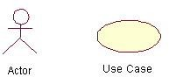

The actors are connected by lines to the use cases that they carry out. The use cases are placed in a rectangle but the actors are not .This rectangle is a visual remainder of the system boundaries and that the actors are outside the system.

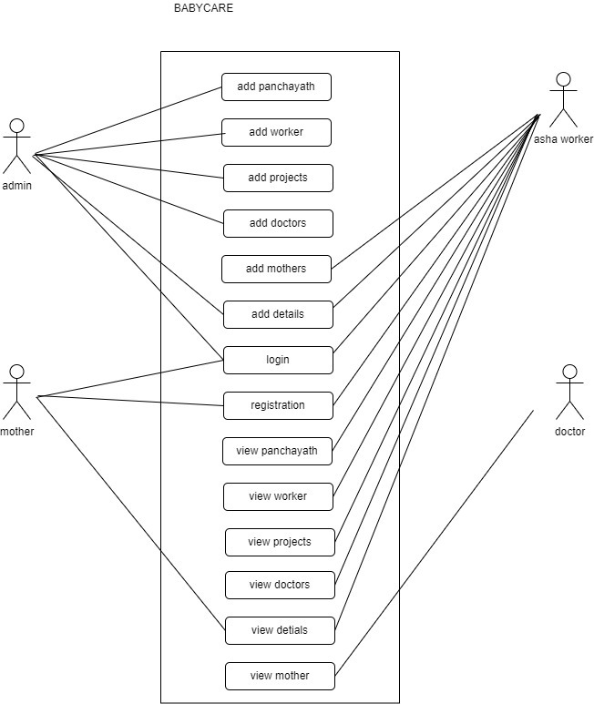

#### **6.2.3** **Uml Model**

The Unified Modeling Language (UML) offers a way to visualize a system’s blueprints in a diagram. Including element such as:

* + - * Any activities
      * Individual component of the system
      * How the system will run
      * How entities interact with others
      * External user interface
      * The UML has been extended to cover a larger set of design documentation

#### **6.2.4 Activity Diagram**

The UML activity diagram supplements the use case by providing a graphical representation of the flow of interaction within a specific scenario. Similar to the flowchart, an activity diagram use rounded rectangles to imply a specific system function, arrows to represent flow through the system, decision diamonds to depict a branching decision, and solid horizontal lines to indicate that parallel activities are occurring.

#### **Data Modeling**

If software requirements include the need to create, extend, or interface with a database, the software team may choose to create a data model as part of overall requirements modeling. It defines all data objects that are processed within the system, the relationship between the data objects, and other information that is pertinent to the relationships. The entity relationship diagram(ERD) addresses these issues and represents all data objects that are entered, stored, transformed, and produced within an application. Data modeling tools provide a software engineer with the ability to represent data object, their characteristics, and their relationships. Used primarily for large database applications and other information systems projects, data modeling tools provide an automated means for creating comprehensive entity relation diagrams, data object dictionaries, and related models.

An E-R diagram may also indicate the cardinality of a relationship. Cardinality is the number of instances of one entity that can, or must, be associated with each instance of another entity. In general we may speak of one-to-one, one-to-many, or many-to-many relationships.

**Rectangle** which represents entity sets.

**Diamond** which represents relationship sets.

**Ellipse which** represents attributes.

**Lines** which link attributes to entity sets and entity sets to relationship sets.

**6.2.6 ER Diagram**

* + 1. **Data flow Diagram (DFD)**

The data flow diagram (DFD) is one of the most important tools used by system analysts. Data flow diagrams are made up of a number of symbols, which represent system components. Most data flow modeling methods use four kinds of symbols. These symbols are used to represent four kinds of system components. Possesses, data stores, data flows and external entities are the components. Circles in DFD represent a process. Data flow is represented by a thin line in DFD and square or rectangle represents external entities.

Unlike detailed flow chart, data flow diagrams do not supply detailed description of the modules but graphically describes a system’s data and how the data interact with the system.

Symbols used in DFD are:

Square, this defines source or destination of data Arrow, which shows data flow

Circle, which represents a process that transforms incoming data into outgoing flow

Open rectangle, which shows a data store

Arrow,it defines data flow.it is a pipeline through which informat

#### **EVEL 0**

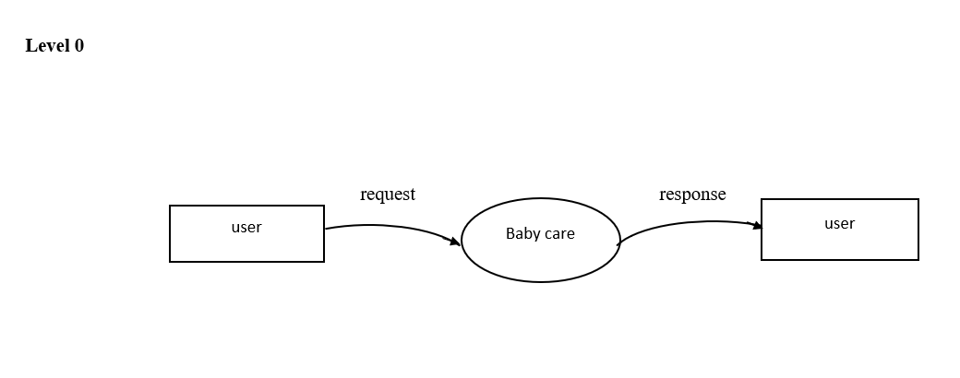

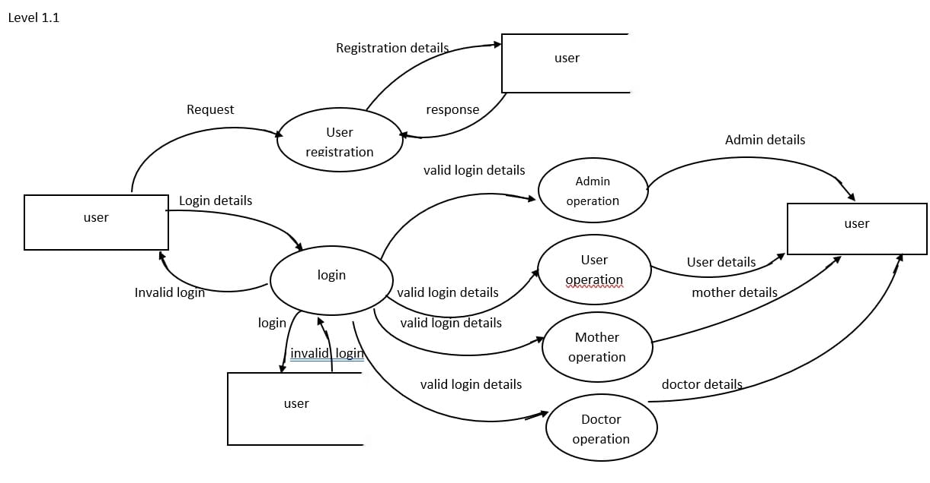

**LEVEL 1.1**

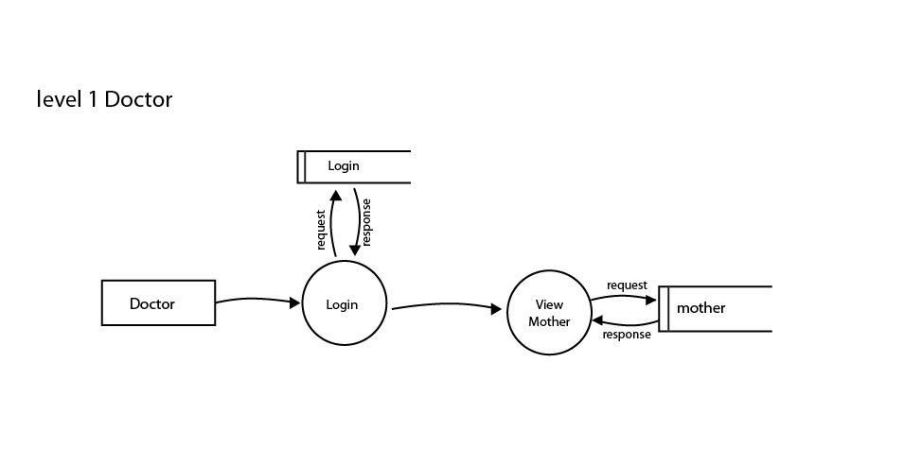

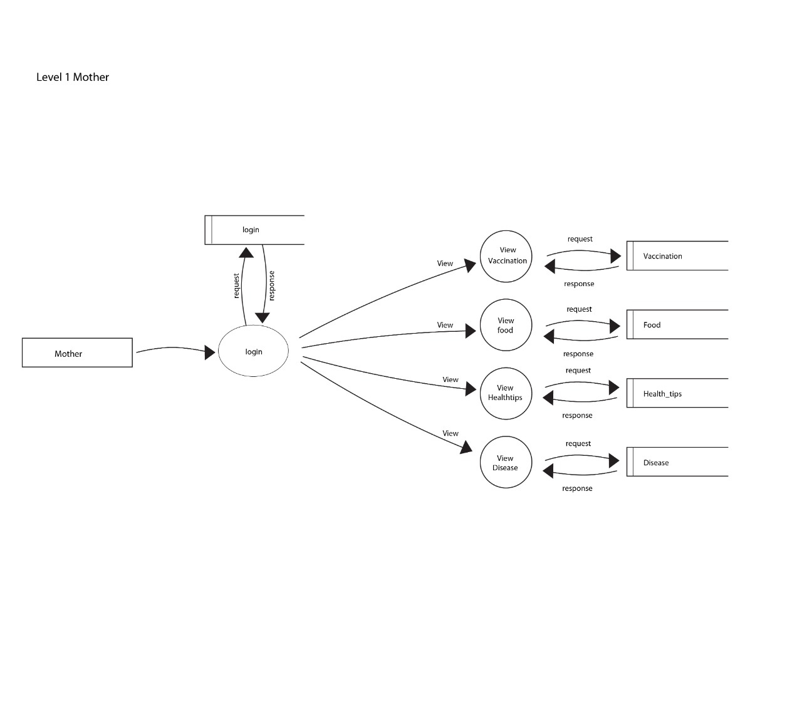

**7. SYSTEM DESIGN**

## INTRODUCTION

System design is the process of defining the Architecture, modules, interfaces, and data for a system to satisfy specified requirements. System design could be seen as the application of systems theory to product development. There is some overlap with the disciplines of system analysis, systems architecture and systems engineering.

#### **TYPES OF SYSTEM DESIGN**

**Logical Design**

Logical design pertains to an abstract representation of the data flow, inputs and outputs of the system. It describes the inputs (source), outputs (destinations), databases (data stores), procedures (data flows) all in a format that meets the user requirements.

#### **Physical Design**

Physical design relates to the actual input and outputs processes of the system. It focuses on how data is entered into a system, verified, processed and displayed as output.

#### **Architectural Design**

It is also known as high level design that focuses on the design of system architecture. It describes the structure and behavior of the system. It defines the structure and relationship between various modules of system development process.

#### **Detailed Design**

It follows Architectural design and focuses on development of each module.

#### **Conceptual Data Modeling**

It is representation of organization data which includes all the major entities and relationship. System analysis develop a conceptual data model for the current system that supports the scope and requirement for the proposed system.

## INPUT DESIGN

Input design is a part of the overall design. The input methods can be broadly classified. Internal controls must be established for monitoring the number of inputs and for ensuring that the data are valid. The basic steps involved in input design are:

* Review input requirements.
* Decide how the input data flow will be implemented.
* Decide the source document.
* Prototype on line input screens.
* Design the input screens.

The quality of the system input determines the quality of the system output. Input specifications describe the manner in which data enter the system for processing. Input design features can ensure the reliability of the system and produce result.

#### **OUTPUT DESIGN**

A quality is one, which meets the requirements of end user and present the information clearly. In any system results of processing are communicated to the user and to the other system through outputs. In the outputs design it is determined how the information is to be displayed for immediate need.

It is the most important and direct source information is to user. Efficient and intelligent output design improves the system’s relationships with the user and helps in decision making. The objectives of the output design is to convey the information of all the past activities, current status and to emphasis important events. The output generally refers to the results and information that is generated from the system. Outputs from computes are required primarily to communicate the result of processing to the users.

Output also provides a means of storage by coping the results for later reference in consolation. There is a chance that some of the end users will not actually operate the input data or information through workstations, but will see the output from the system.

Two phases of the output design are:

1. Output Definitions
2. Output Specification

Output definitions takes into account the type of outputs contents, its frequency and its volume, the appropriate outputs media is determined for output. Once the media is chosen, the details specification of output documents are carried out. The nature of output required from the proposed system is determined during logical design stage. It takes the outline of the output from the logical design and produces output as specified during the logical design phase. In a project, when designing the output, the system must accomplish the following:

* Determine the information to present.
* Decide whether to display, speak the information and select the output medium.
* Arrange the information in acceptable format.
* Decide how to distribute the output to the intended receipt.

Thus, by following the above specification, a high-quality output can be generated. Outputs from compute system are required primarily to communicate thee result of processing to users. Computer output is the most important and direct source of information to the user. Efficiency, intelligible output should improve the system’s relationship with the user and help in decision making. The output devices to consider depend on factors as compatibility of the device with the system, response time requirements, expected print quality, number of copies needed etc.

## DATA BASE DESIGN

A database is a collection of interrelated data stored with minimum redundancy to serve many users quickly and efficiently. The general objective is to make information access easy, quick, inexpensive and flexible for users. The general theme behind a database is to integrate all information. Database design is recognized as a standard of management information system and is available virtually for every computer system. In database design several specific objectives are considered:

* Ease of learning and use
* Controlled redundancy
* Data independence
* More information at low cost
* Accuracy and integrity
* Recovery from failure
* Privacy and security

#### **NORMALIZATION**

Designing a database is complete task and the normalization theory is a useful aid in the design process. The process of normalization is concerned with transformation of conceptual schema into computer representation form. There will be need for most databases to grow by adding new attributes and new relations. The data will be used new ways. Tuple will be added and deleted. Information stored may undergo updating also. New association may also be added. In such situation the performance of a database is entirely depend upon its design. A bad database design may lead to certain undesirable things like:

1. Repetition of information
2. Inability to represent certain information
3. Loss of information

To minimize these anomalies, normalization may be used. If the database is in a normalized from, the data can be growing without, in most cases, forcing the rewriting application programs. This is important because of the excessive and growing cost of maintaining an organization’s application programs and its data from the disrupting effects of database growth. As the quality of application programs increase, the cost of maintaining the without normalization will rise to prohibitive levels, A normalized database can also encompass many related activities of an organization thereby minimizing the need for rewriting the applications of programs. Thus, normalization helps one attain a good database design and there by ensures continued efficiency of database.

We can define the procedure as the successive reduction of a given collection of relations to some more desirable from. This procedure is reversible. That is, it is always possible to take the output from the procedure and convert them back into input. In this process, no information is lost. So, it is also called “no lose decomposition”.

**First normal form:** A relation is first normal form (1NF) if and all its attributes are based on single domain. The objective of normalization a table is to remove its repeating groups and ensure that all entries of the resulting table have at most single value.

**Second normal form:** A table is said to be second normal form (2NF), when it is in 1NF and every attribute in the record is functionally dependent upon the whole key, and not just a part of the key.

**Third normal form:** A table is in third normal form (3NF). When it is in 2NF and every non-key attribute is functionally dependent on just the primary key.

## 7.5 TABLE DESIGN

The design of the tables in the database is done according to the rules specified for database. In the proposed project, 10 tables are used and some of them are connected using foreign keys. Insertion and retrieval of values are easy by designing the database in this way.

#### Table name: disease

|  |  |  |
| --- | --- | --- |
| Field | Type | Constraint |
| disease_id | int (4) | Primary key |
| wrkr_id | int (4) | Not null |
| doc_id | int (4) | Not null |
| Details | varchar (50) | Not null |
| posted_date | Date | Not null |

1. **Table name: doctor**

|  |  |  |
| --- | --- | --- |
| Field | Type | Constraint |
| doctor_id | int (4) | Primary key |
| District | varchar (50) | Not null |
| Panchayath | varchar (50) | Not null |
| Dname | varchar (50) | Not null |
| Qualification | varchar (50) | Not null |
| Address | varchar (50) | Not null |
| phone_no | varchar (50) | Not null |
| Optime | varchar (50) | Not null |

1. **Table name: food**

|  |  |  |
| --- | --- | --- |
| Field | Type | Constraint |
| food_id | int (100) | Primary key |
| worker_id | int (100) | Not null |
| Title | varchar (50) | Not null |
| Details | varchar (100) | Not null |
| posted_date | Date | Not null |
| Status | varchar (50) | Not null |

1. **Table name: health_tips**

|  |  |  |
| --- | --- | --- |
| Field | Type | Constraint |
| Tipid | int (100) | Primary key |
| wrkr_id | int (100) | Not null |
| age_grp | varchar (50) | Not null |
| Tips | varchar (100) | Not null |
| posted_date | Date | Not null |
| Status | varchar (20) | Not null |

1. **Table name: login**

|  |  |  |
| --- | --- | --- |
| Field | Type | Constraint |
| logid | int (100) | Primary key |
| userid | int (100) | Not null |
| username | varchar (100) | Not null |
| password | varchar (50) | Not null |
| status | varchar (10) | Not null |
| Usertype | varchar (50) | Not null |

1. **Table name:mother_reg**

|  |  |  |
| --- | --- | --- |
| Field | Type | Constraint |
| mother_id | int (100) | Primary key |
| wrkr_id | int (100) | Not null |
| mother_name | varchar (50) | Not null |
| Age | varchar (20) | Not null |
| Address | varchar (100) | Not null |
| District | varchar (50) | Not null |
| Panchayath | varchar (50) | Not null |
| ward_no | varchar (50) | Not null |
| Pstatus | varchar (20) | Not null |
| month_count | varchar (10) | Not null |
| delivery_date | Date | Not null |
| phone_number | varchar (10) | Not null |

1. **Table name: panchayath_reg**

|  |  |  |
| --- | --- | --- |
| Field | Type | Constraint |
| panchayath_id | int (100) | Primary key |
| Name | varchar (50) | Not null |
| District | varchar (25) | Not null |
| ward_count | varchar (20) | Not null |
| house_count | varchar (20) | Not null |
| president_name | varchar (25) | Not null |
| address | varchar (100) | Not null |
| email | varchar (50) | Not null |
| phone_number | varchar (10) | Not null |

**8. Table name: projects**

|  |  |  |
| --- | --- | --- |
| Field | Type | Constraint |
| project_id | int (100) | Primary key |
| District | varchar (50) | Not null |
| Panchayath | varchar (50) | Not null |
| Title | varchar (100) | Not null |
| Details | varchar (200) | Not null |
| posted_date | Date | Not null |
| valid_upto | Date | Not null |
| Status | varchar (10) | Not null |

1. **Table name: worker_reg**

|  |  |  |
| --- | --- | --- |
| Field | Type | Constraint |
| wrkr_id | int (100) | Primary key |
| district | varchar (50) | Not null |
| panchayath | varchar (50) | Not null |
| worker_name | varchar (50) | Not null |
| phone_no | varchar (10) | Not null |
| ward_no | varchar (20) | Not null |
| address | varchar (100) | Not null |
| email | varchar (50) | Not null |
| qualification | varchar (50) | Not null |

F F FVVVV

# CODING

#### **SOURCE** **CODE** **Login**

<!DOCTYPE html>

<html>

<head>

<script>

function noBack() { window.history.backward()

}

noBack();

window.onload = noBack;

window.onpageshow = function (evt) { if (evt.persisted) noBack()

} window.onunload = function () { void (0) }

</script>

<title>Baby Care a Society & People Flat Bootstrap responsive Website Template | Contact :: w3layouts</title>

<meta name="viewport" content="width=device-width, initial-scale=1">

<meta http-equiv="Content-Type" content="text/html; charset=utf-8"/>

<meta name="keywords" content="Baby Care Responsive web template, Bootstrap Web Tem plates, Flat Web Templates, Android Compatible web template,

Smartphone Compatible web template, free webdesigns for Nokia, Samsung, LG, SonyEricsson

, Motorola web design" />

<script type="application/x-

javascript"> addEventListener("load", function() { setTimeout(hideURLbar, 0); }, false); functio n hideURLbar(){ window.scrollTo(0,1); } </script>

<link href='{% static "css/bootstrap.css" %}' rel='stylesheet' type='text/css' />

<link href='{% static "css/style.css" %}' rel='stylesheet' type='text/css' />

<link href='{% static "css/owl.carousel.css" %}' rel="stylesheet">

<script src='{% static "js/jquery.min.js" %}'></script>

<script type = "text/javascript" > window.onbeforeunload=function(){return "cant redirect";};

</script>

</head>

<body>

<!--header-top-->

<div class="header-top">

<div class="container">

<div class="head-main">

<div class="col-md-4 head-middle">

<h1><a href="/">Baby Care</a></h1>

</div>

<div class="col-md-4 head-left">

<ul>

<li><a href="#"><span class="fb"> </span></a></li>

<li><a href="#"><span class="twit"> </span></a></li>

<li><a href="#"><span class="pin"> </span></a></li>

<li><a href="#"><span class="rss"> </span></a></li>

</ul>

</div>

<div class="clearfix"></div>

</div>

</div>

</div>

<!--header-top-->

<!--navigation-starts-->

<div class="navigation">

<span class="menu"></span>

<ul class="navig cl-effect-16">

<li><a href="/">Home</a></li>

<li><a href="login/">Login</a></li>

</ul>

</div>

<!--navigation-end-->

<!--script-for-menu-->

<script>

$("span.menu").click(function(){

$(" ul.navig").slideToggle("slow" , function(){

});

});

</script>

<!--script-for-menu-->

<!--banner-starts-->

<div class="banner-1">

</div>

<!--banner-end-->

<!--contact-->

<div class="Registeration">

{%if message%}

<script>

alert('{{message}}');

</script>

{%endif%}

<form action="#" method="post">

<center><h2>LOGIN</h2>

<div class="contact-bottom">

<form action="#" method="post">

{% csrf_token %}

<table>

<tr><input placeholder="Username" name="username" style="width: 680px;height: 50 px" type="text" required=""></tr><br><br>

<tr><input placeholder=" Password" name="pass" type="password" style="width: 680p x;height: 50px" required=""> </tr>

</table>

<div class="submit-btn">

<input type="submit" value="SUBMIT">

</form>

</div>

</center>

</div>

</div>

</div>

<br><br>

<!--contact-->

<!--footer-starts-->

<div class="footer">

<div class="container">

<div class="footer-top">

<div class="col-md-6 footer-right">

<form action="#" method="post">

<input type="text" value="Your Email" name="email" onfocus="this.value = '';" onblur="if (thi s.value == '') {this.value = 'Your Email';}">

<input type="submit" value="Subscribe">

</form>

<p>© 2016 Baby Care. All Rights Reserved | Design by <a href="[http://w3layouts.c](http://w3layouts.c/) om/" target="_blank">W3layouts</a> </p>

</div>

<div class="col-md-3 footer-left">

<div class="a-1">

<span class="glyphicon glyphicon-map-marker" aria-hidden="true"></span>

<p>The company name, Glasglow Dr 40 Fe 72.</p>

</div>

<div class="a-2">

<span class="glyphicon glyphicon-envelope" aria-hidden="true"></span>

<p><a href="<mailto:example@email.com>"[>c](mailto:contact@example.com)o[ntact@example.com](mailto:contact@example.com)</a></p>

</div>

</div>

<div class="col-md-3 footer-left">

<div class="a-1">

<span class="glyphicon glyphicon-earphone" aria-hidden="true"></span>

<p>+122 265 8822</p>

</div>

<div class="a-2">

<span class="glyphicon glyphicon-phone-alt" aria-hidden="true"></span>

<p>+134 326 3695</p>

</div>

</div>

## 

## 9. APPENDIX

# 

* 1. **SAMPLE INPUT SCREENS**

**Home page**

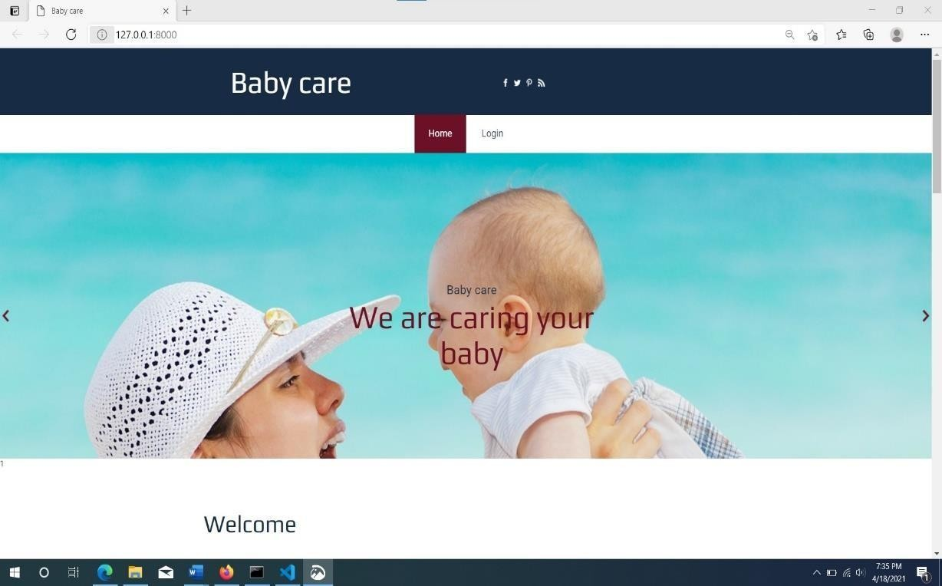

**Admin login page**

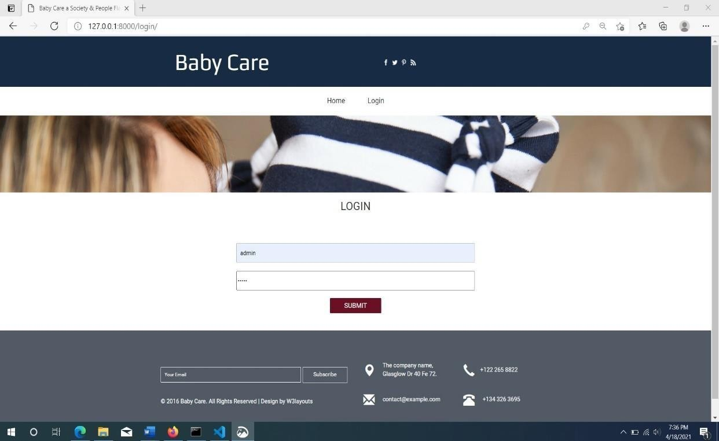

**Admin home page**

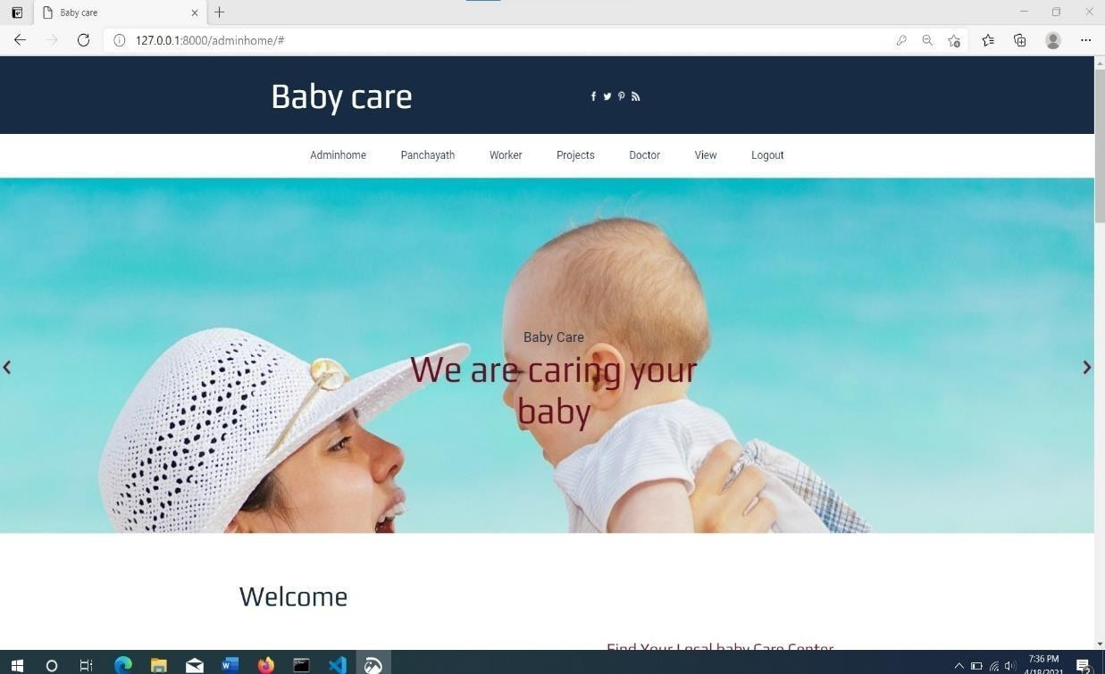

**Panchayath registration page**

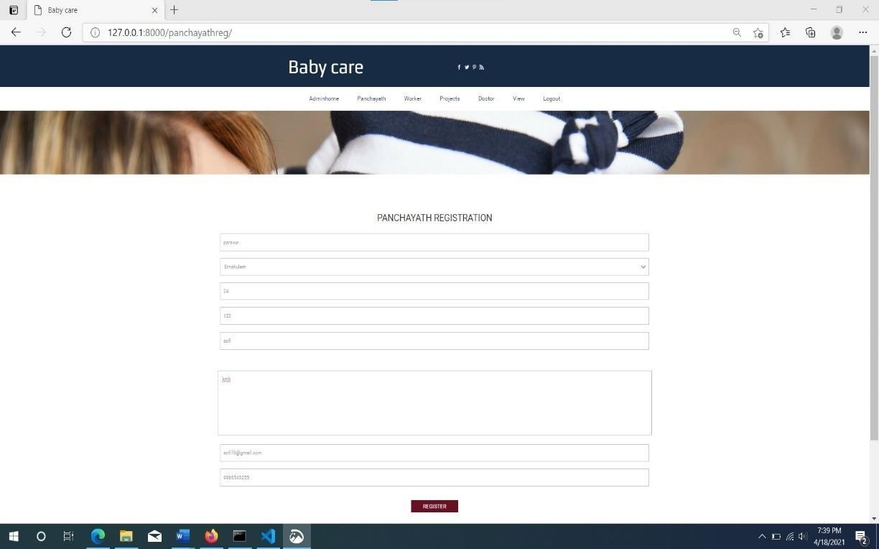

**Add doctor page**

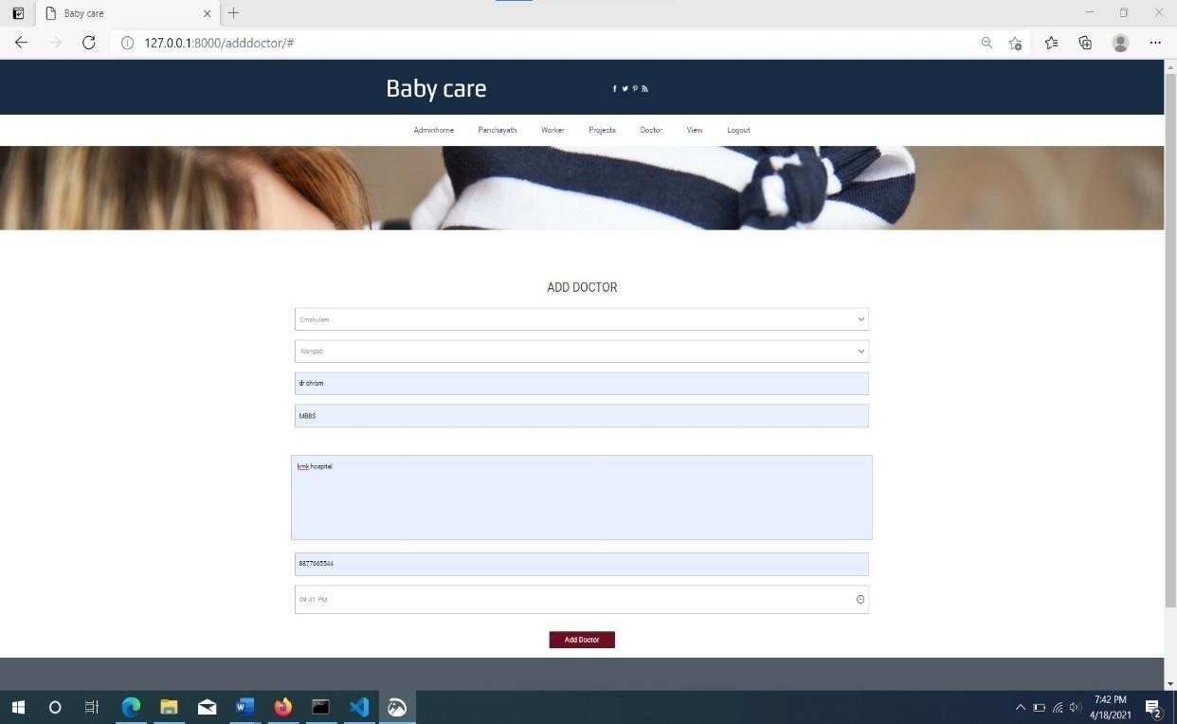

**Asha worker login page**

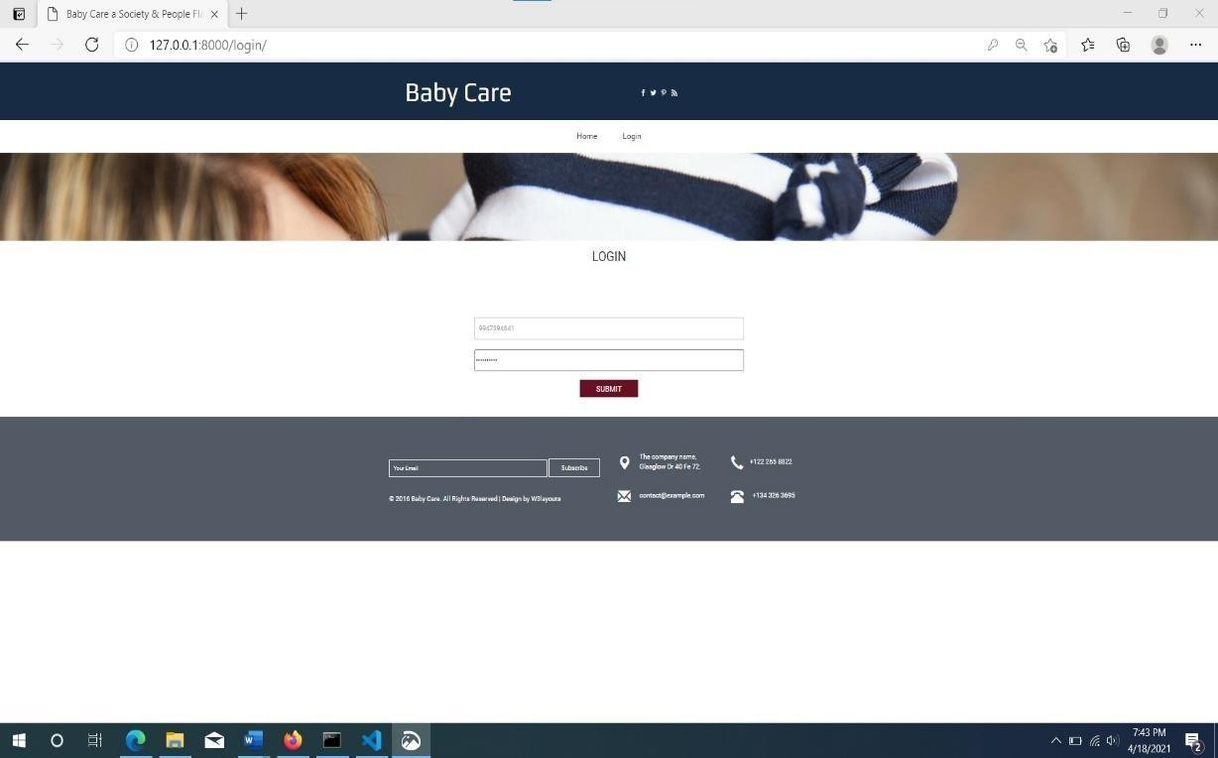

**Asha worker home Page**

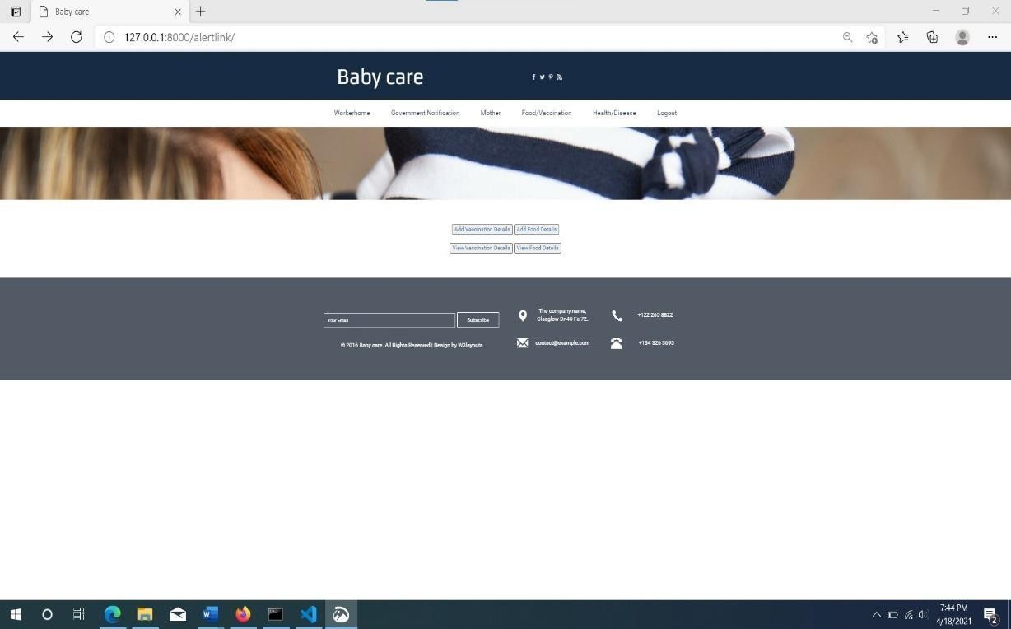

**Add vaccination page**

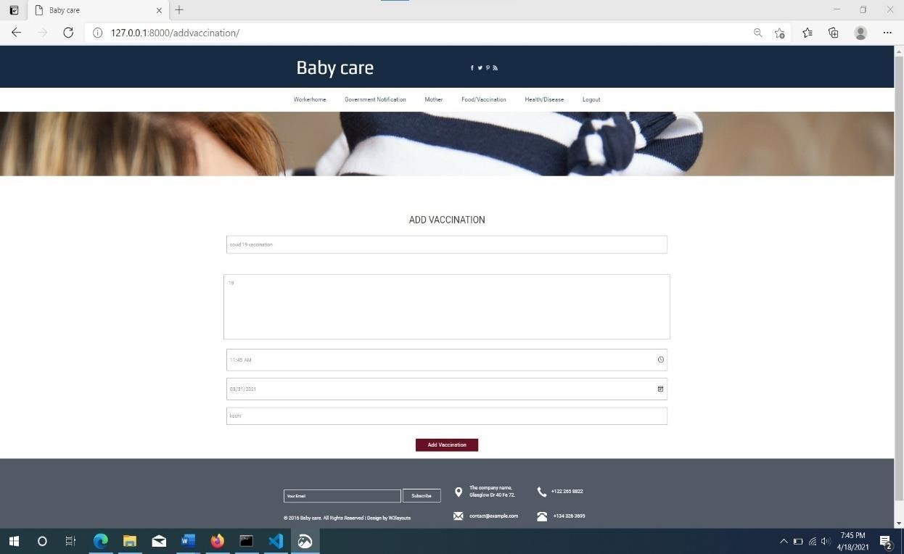

**View vaccination list**

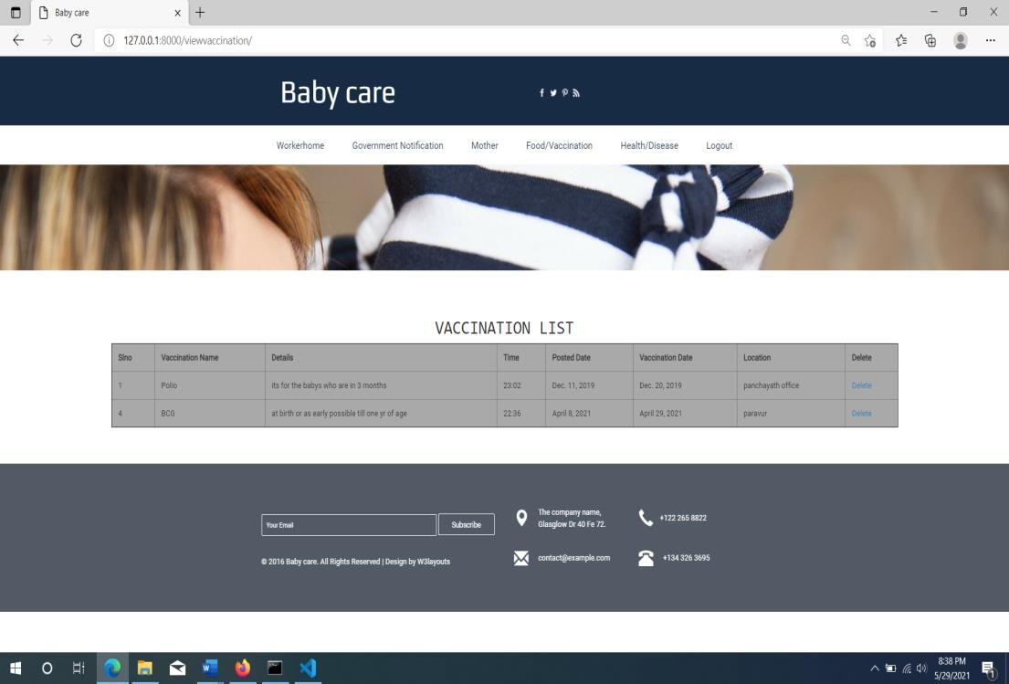

**Government notification**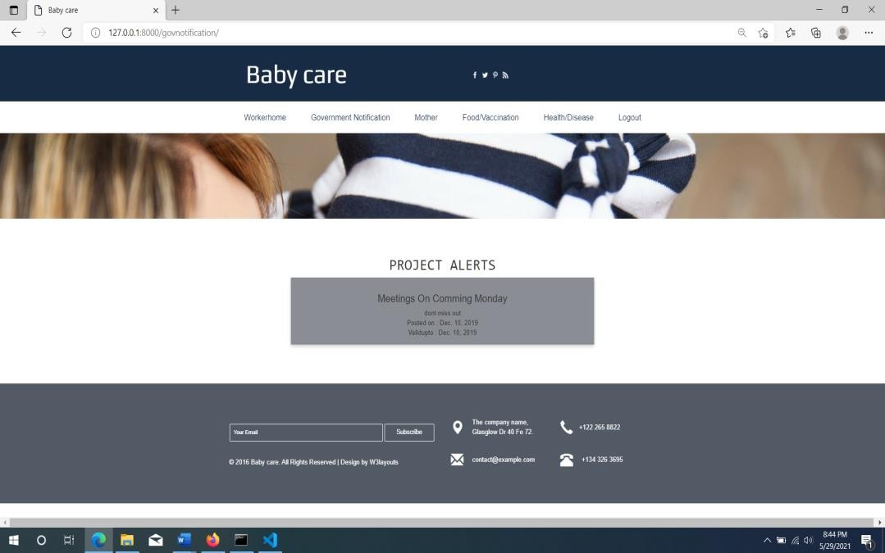

**Doctor login**

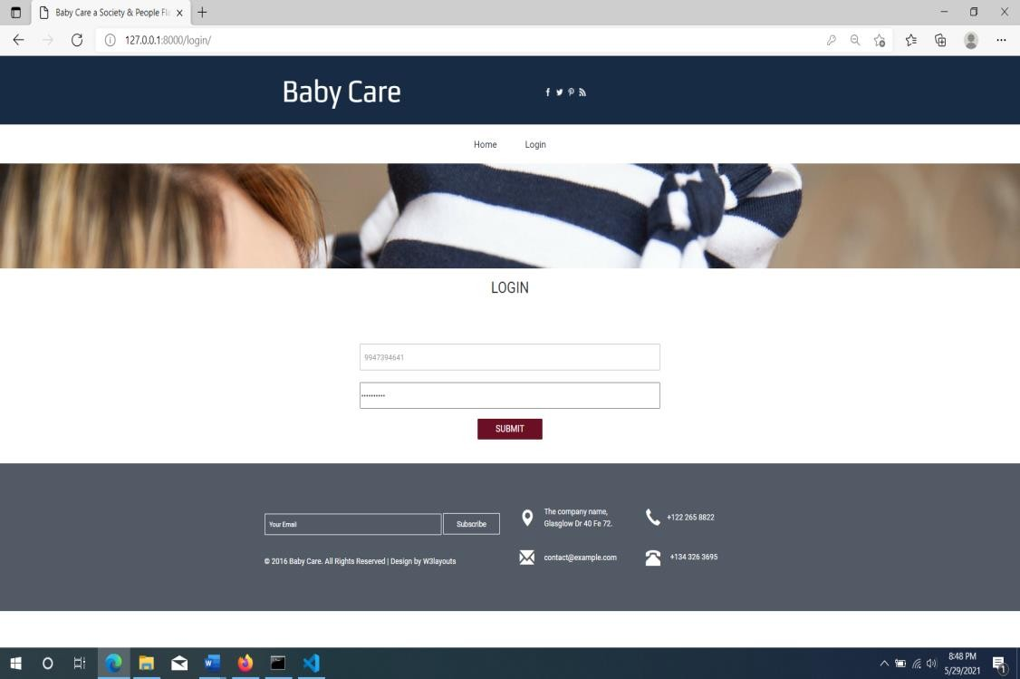

**Doctor home**

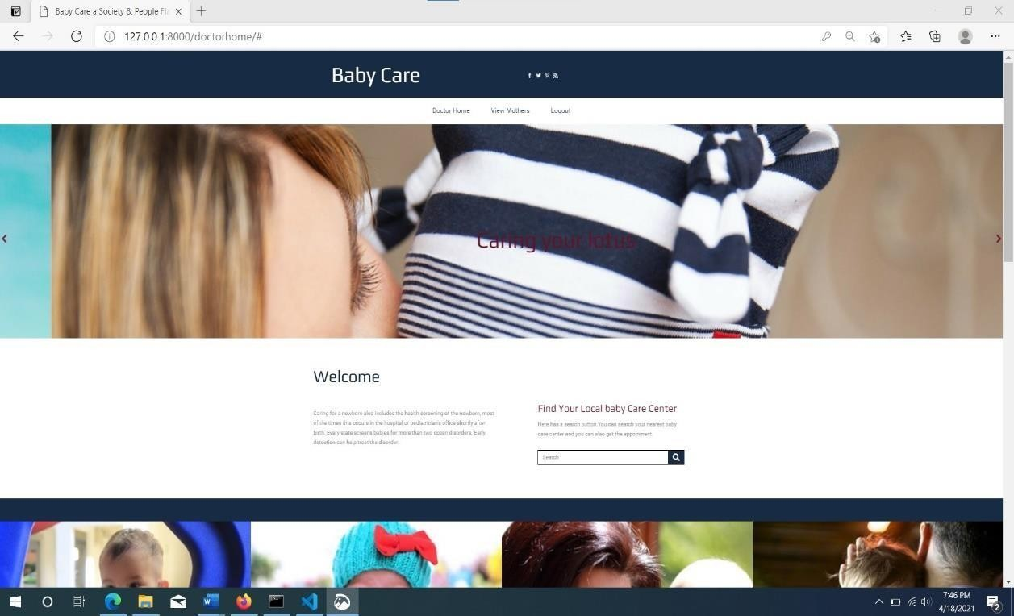

**Mother login**

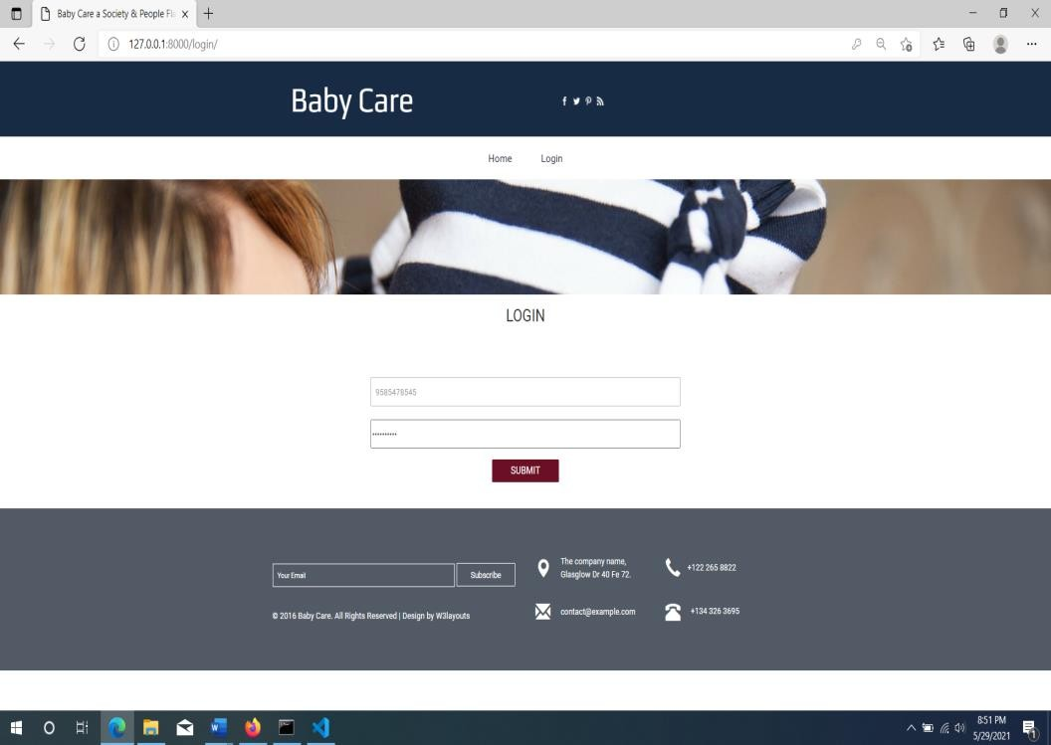

**Mother home page**

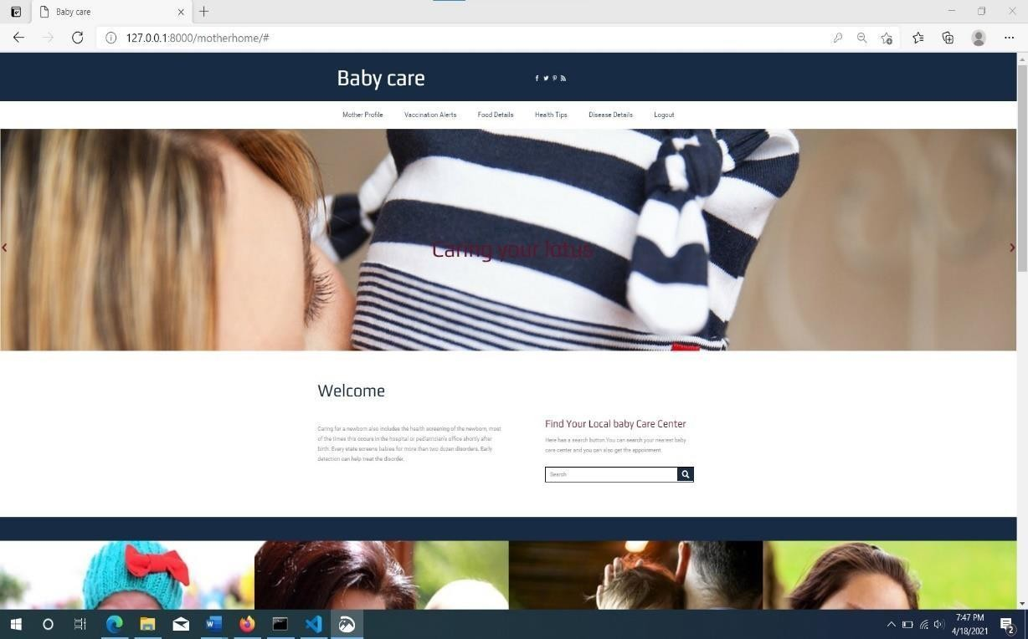

# . FUTURE SCOPE OF PROJECT

**FUTURE ENHANCEMENT**

Enhancements are the perquisite for development of a system. Every existing system has proposed enhancement which make it better and easier to use and more secure. This project we can add video call consultancy by doctors in future.

ASHA was developed and is successful in its endeavors so long it will remain

successful in the future in its activities of women and child empowerment.

The drawbacks of the existing system as listed before are fully evacuated. All the existing inconsistencies are fully solved as this system is implemented. As a future enhancement, the major advantage of the system is:

1. Reduced workload
2. Reduce paper work
3. Provide security
4. Time saving

**11 . CONCLUSION**

**CONCLUSION**

The project brings the entire manual process of work of an asha worker online. The main purpose of this project is to simplify the process of handling each event by providing a web interface for admin, worker and parents, doctors. The admin module consists of register each worker and allot each worker to different locations and view the overall work of worker. The worker module consists of register parent have child less than 5 years old, providing baby food, alert vaccination details, date of vaccination, manage the health of both mother and child, add details of diseases etc. The parent module consists view the view the vaccination details, view the details about the nutrition foods, diseases so and so.

The developed software meets most of the requirements and every effort has been done to make the shop work simpler and easier. The software developed is implemented and tested successfully. It provides maximum security and is user friendly. This project was successfully completed within the time span allotted. All the modules are tested separately and put together to form the main system. Finally, the system is tested with real data and everything worked successfully. Thus, the system has fulfilled the entire objective identified. The system had been developed in an attractive dialog fashion. So, user with minimum knowledge about computers can also operate the system easily.

# 12 . BIBLIOGRAPHY

## REFERENCES

1. AN INTRODUCTION TO PYTHON - Guido van Rossum
2. HTML 5 & CSS MADE SIMPLE - Ivan Bayross
3. JAVASCRIPT: THE DEFINITIVE GUIDE - David Flanagan
4. THE DEFINITIVE GUIDE TO USING,

PROGRAMMING AND ADMINISTERING MYSQL4 - Paul DuBois

## WEBSITES VISITED

[www.google.com](http://www.google.com/) [www.w3schools.com](http://www.w3schools.com/) [www.wikipedia.com](http://www.wikipedia.com/)